AVILA BEACH
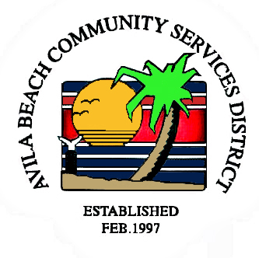
COMMUNITY SERVICES DISTRICT
Post Office Box 309, Avila Beach, CA 93424
Office and Meeting Room - 100 Street, Avila Beach
Telephone (805) 595-2664
e-mail: avilacsd@gmail.com

Payment Arrangement for Outstanding Water & Sewer Services

I,_______________________, agree to repay $_______________over 24 months in monthly installments of $______________in addition to the monthly water and sewer bill. Payments will be made by the ________ day of each month.
BEGINNING DATE OF REPAYMENT SCHEDULE: _____________________________.

If a check written “bounces” a charge of $35.00 shall be added to the unpaid balance of the loan, and all future payments will only be accepted in guaranteed funds such as cash, money order, or certified check.

If the entire balance due is not paid by_____________________, or if a payment is not made for more than thirty days after it is due, the Avila Beach Community Service District shall be granted the ability to demand the entire balance due and may take any legal actions that are necessary to collect the above-mentioned amount.

If there are any additional costs for collecting the said amount it be added to the balance of the amount owed by the District. If the debt goes to collection the interest and late fees will apply.

This contract shall be governed by the laws of the State of California in the County of San Luis Obispo and any applicable Federal Law.

Signed:______________________________________ Date:__________________________

Subject Property:_______________________________________________________________

